Misfolded protein aggregate conditions, such as Parkinson’s disease (PD) and Alzheimer’s disease (AD), are challenging to treat because the molecular mechanisms of the protein assembly and degradation are poorly understood. To effectively treat these conditions, we need to understand both a structural means of aggregate recognition, out of a complex biological environment, and a chemical means of effecting their dissolution. Fortunately, novel methods have in recent years yielded greater structural clarity. Combining the available structural data, experimentally derived information about molecular behavior, and computational modeling, we are now poised to complete the picture.

Several important fibril structures have now been determined. The structure of α-synuclein, implicated in PD, was resolved by solid state nuclear magnetic resonance (ssNMR) in 20161. Tau protein, implicated in AD, was imaged in 2017 by cryo-electron microscopy (CEM)2. Meanwhile, a 2012 report identified a protein capable of degrading tau fibrils, Htra13. Htra1 is a multi-domain protein, including an N-terminal region including an insulin-like growth factor binding (IGFB) motif and a Kazal 2 structure, a serine protease middle domain4, and a C-terminal PDZ domain5, with all three domains connected flexibly. Structures for each domain have been determined with usable resolution, but not for the trimeric structure assumed by the full protein, thus characterization of the interactions between the domains, and the regulatory influences those interactions might have on proteolytic activity and substrate specificity, remains speculative.

A considerable body of work has been invested into elucidating the behavior of Htra1, due to its diverse roles in a number of natural processes and medical conditions6. For our purposes, the biochemical studies of Htra1’s substrate recognition in the PDZ domain5 and protease domain4,7, and tau-specific degradation behavior3,8, are of particular interest. Htra1 exhibits promiscuity in its substrate selection, both for the PDZ, which is suspected to bind first, and for the proteolytic domain. The PDZ coordinates substrate binding by coordinating the peptide into a β-sheet with part of the PDZ, recognizing a 4-residue region. An alanine scan demonstrated that the PDZ’s substrate binding affinity, and therefore its selectivity, was highly sensitive to even single point mutations7. The native PDZ prefers C-terminal peptides with predominantly hydrophobic character, yet some internal regions are also bound. A study on a similar PDZ protein, nNOS, indicated that internal region binding was possible if the substrate peptide included a sharp β-finger turn9. Such a turn is notably absent in the tau fibril structure, in which β-sheets are formed between separate chains, leaving the internal binding mode of Htra1 PDZ to the tau fibril an open question.

In bacterial homolog DegS, it was shown that before binding a substrate peptide, the PDZ domain formed an interaction with loop L3 of the proteolytic domain, which in turn produced a steric change to the catalytic triad, inactivating it. Activity was restored when the PDZ underwent steric changes in response to substrate binding, which produced a corresponding allosteric change to the proteolytic domain10,11. However, that is not the regulatory mechanism for Htra1. It was demonstrated that Htra1 protease domain exhibited catalytic activity when the PDZ was deleted, though there was a change in the length of hydrolysis products7,8, and though the full trimeric structure has not been determined in high resolution, SAXS experiments suggest that the PDZ domains are positioned far from the catalytic structure4.

The presence or absence of the N-terminal domain seems to have little impact on catalytic activity on tau, so its role is still unknown. Instead, it was thought that catalytic activity in the protease domain was activated by induced fit3,7. However, it was shown that even in the absence of substrate peptide or peripheral domains, the proteolytic domain samples both active and inactive structures, suggesting an equilibrium between several low energy states in solution4, thus substrate binding may be described by conformer selection. This would be convenient from a computational modeling standpoint, since it is more difficult, though possible12, to sample sufficient degrees of freedom to adequately represent fit induction. However, it was also demonstrated that Htra1, both with and without the PDZ, had increased activity on synthetic peptide substrates in the presence of tau3, though the specific molecular interaction promoting 4- to over 20-fold increases in activity was not identified. Further complicating the elucidation of this mechanism was the PDZ-independent formation of larger multimers associated with the activity increase7,13; whether such large assemblies are able to interact with tau fibrils, or whether Htra1’s interaction with tau takes place in trimeric or monomeric form, is unknown. Observation of the proximity between loops L3 and LD* of neighboring protease domains in the crystal structure suggest that their conformational changes may be of significant influence6.

Htra1’s interaction with tau fibrils is complex indeed, as it combines disintegration of the fibril with hydrolytic degradation. The complex behavior is not isolated to the termini of the fibril, nor does hydrolysis only happen in terminal sections of individual tau proteins, but rather was distributed across the entire fibril, and with cleavages in multiple locations in the tau sequence8. Catalytically inactivated Htra1 degraded tau fibrils, while isolated PDZ did not, indicating that the proteolytic domain’s interaction with tau plays a wider role than hydrolysis alone. Inactive Htra1 was, however, less effective at fibril degradation when the PDZ was deleted, and unable to solubilize tau fibrils. This demonstrates the cooperativity between the domains in disintegrating tau fibrils; the nature of this cooperativity has yet to be determined. Disintegration improved proteolysis; when tau fibrils were pre-treated with catalytically inactive Htra1 prior to mixture with active enzyme; more cuts were made, particularly within the regions of tau that form the fibril core. A representative peptide of tau bound Htra1 and the isolated PDZ with similar affinity.

1. Tuttle, M. D. *et al.* Solid-state NMR structure of a pathogenic fibril of full-length human α-synuclein. *Nat. Struct. Mol. Biol.* **23,** 409–415 (2016).

2. Fitzpatrick, A. W. P. *et al.* Cryo-EM structures of tau filaments from Alzheimer’s disease. *Nature* **547,** 185–190 (2017).

3. Tennstaedt, A. *et al.* Human high temperature requirement serine protease A1 (HTRA1) degrades tau protein aggregates. *J. Biol. Chem.* **287,** 20931–20941 (2012).

4. Eigenbrot, C. *et al.* Structural and functional analysis of HtrA1 and its subdomains. *Structure* **20,** 1040–1050 (2012).

5. Runyon, S. T. *et al.* Structural and functional analysis of the PDZ domains of human HtrA1 and HtrA3. *Protein Sci.* **16,** 2454–2471 (2007).

6. Zurawa-Janicka, D. *et al.* Structural insights into the activation mechanisms of human HtrA serine proteases. *Arch. Biochem. Biophys.* **621,** 6–23 (2017).

7. Truebestein, L. *et al.* Substrate-induced remodeling of the active site regulates human HTRA1 activity. *Nat. Struct. Mol. Biol.* **18,** 386–388 (2011).

8. Poepsel, S. *et al.* Determinants of amyloid fibril degradation by the PDZ protease HTRA1. *Nat. Chem. Biol.* **11,** 862–869 (2015).

9. Hillier, B. J., Christopherson, K. S., Prehoda, K. E., Bredt, D. S. & Lim, W. A. Unexpected modes of PDZ domain scaffolding revealed by structure of nNOS-syntrophin complex. *Science (80-. ).* **284,** 812–815 (1999).

10. Wilken, C., Kitzing, K., Kurzbauer, R., Ehrmann, M. & Clausen, T. Crystal Structure of the DegS Stress Sensor: How a PDZ Domain Recognizes Misfolded Protein and Activates a Protease. *Cell* **117,** 483–494 (2004).

11. de Regt, A. K., Baker, T. A. & Sauer, R. T. Steric clashes with bound OMP peptides activate the DegS stress-response protease. *Proc. Natl. Acad. Sci.* **112,** 3326–3331 (2015).

12. Burman, S. S. R., Marze, N. A., Sheffler, W. & Gray, J. J. Efficient Flexible-Backbone Docking of Challenging Protein Complexes. *Biophys. J.* **114,** 344a (2018).

13. Jo, H., Patterson, V., Stoessel, S., Kuan, C.-Y. & Hoh, J. Protoporphyrins Enhance Oligomerization and Enzymatic Activity of HtrA1 Serine Protease. *PLoS One* **9,** e115362 (2014).

**Experiment ideas**

Sequential isotopic labeling with native chemical ligation and peptide synthesis

CSP on the PDZ domain in the presence and absence of protease including the S238A

HDX on fibril with protease bound (protease should shield from exchange)

N-terminal MS to identify sites of cleavage subtligase

CSP on the protease domain in the presence and absence of PDZ

CSP soluble vs fibril with catalytically inactive protease

Modifying Htra1 to permit single cut then permanent binding (halo tag? Hist mut?)

Hillier, 1999

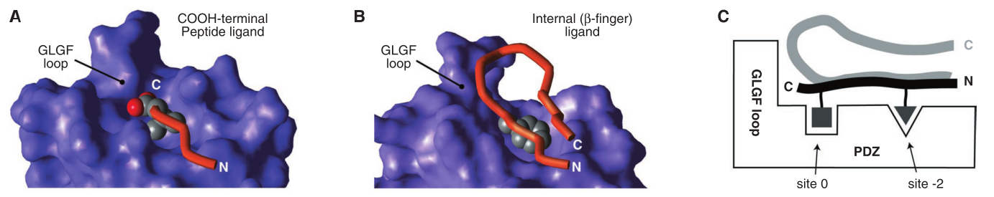

Wilkin, 2004

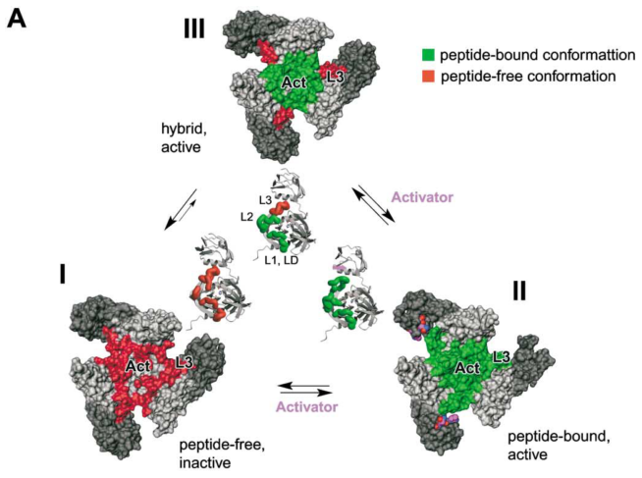

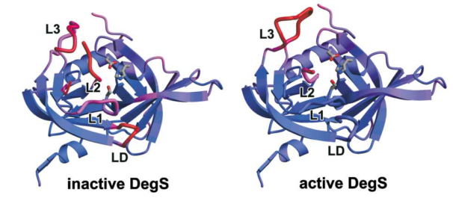

Runyon 2007

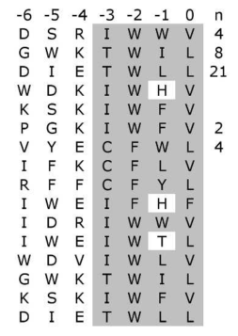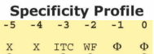 (PDZ, C-termini)

--------------------------------------------------------------------------------🡪

Internal ligands: [G/S/A] [V/L][T/S]WG[E/D]φ[L/V]Xφ[L/V/I], where ‘‘φ’’ is a hydrophobe

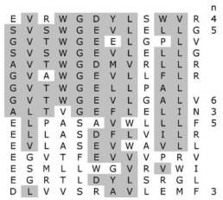Internal acid serves as C-term?

Internal sequences from phage display -----------------🡪

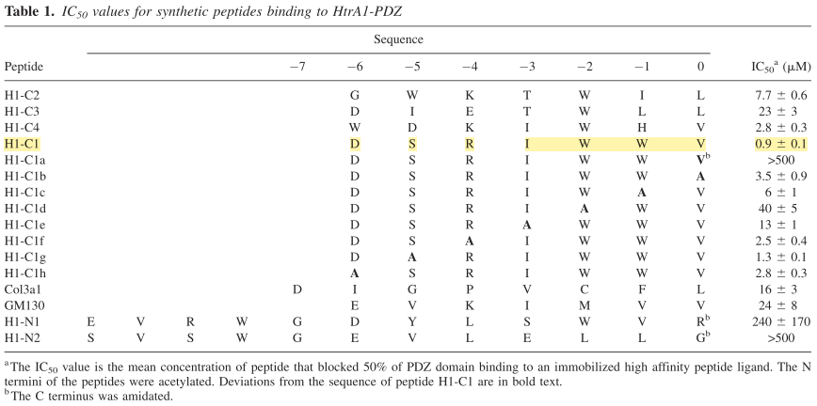

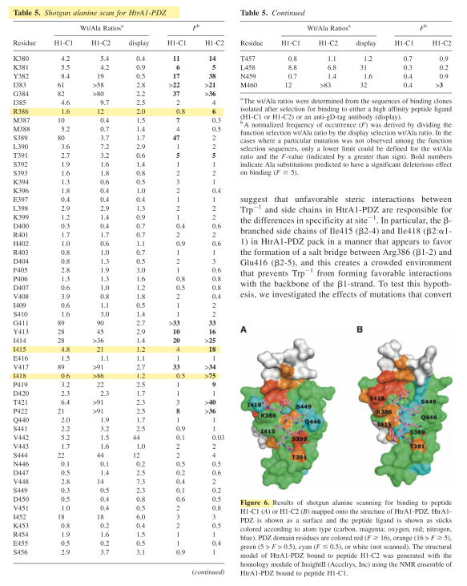

Truebestein 2011

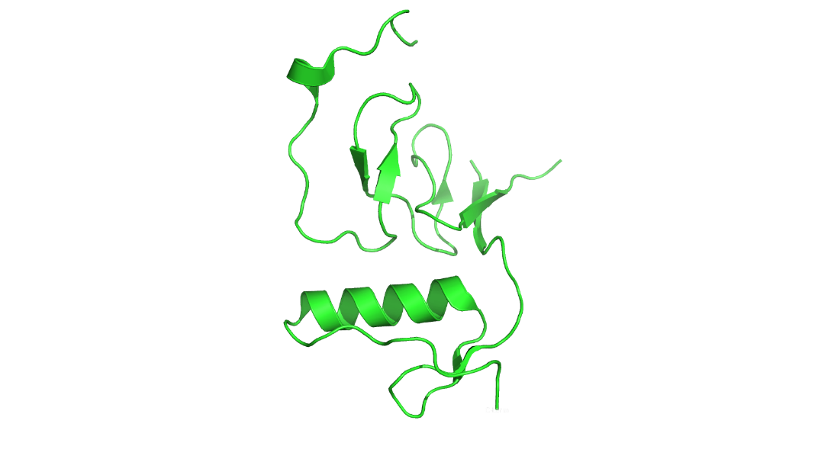Nterm

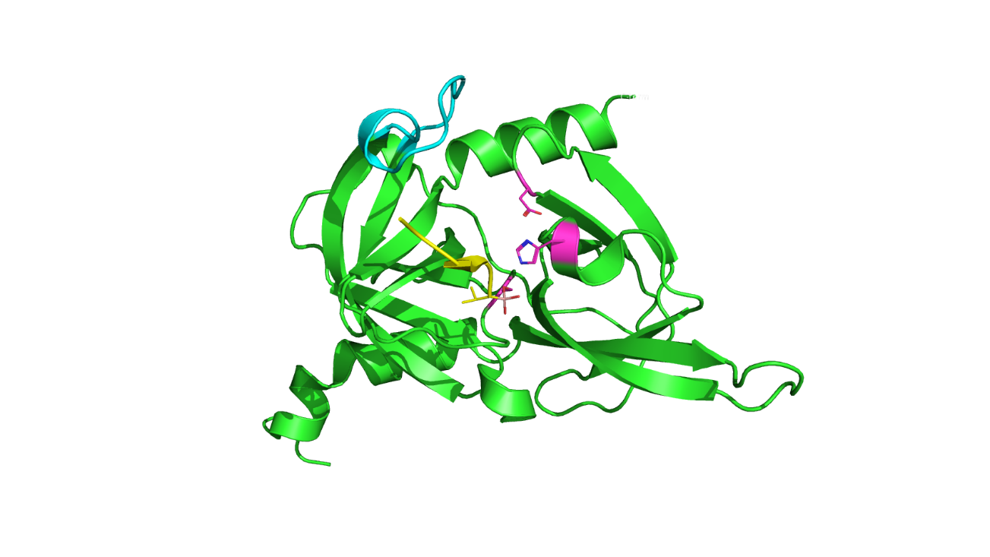 Cat

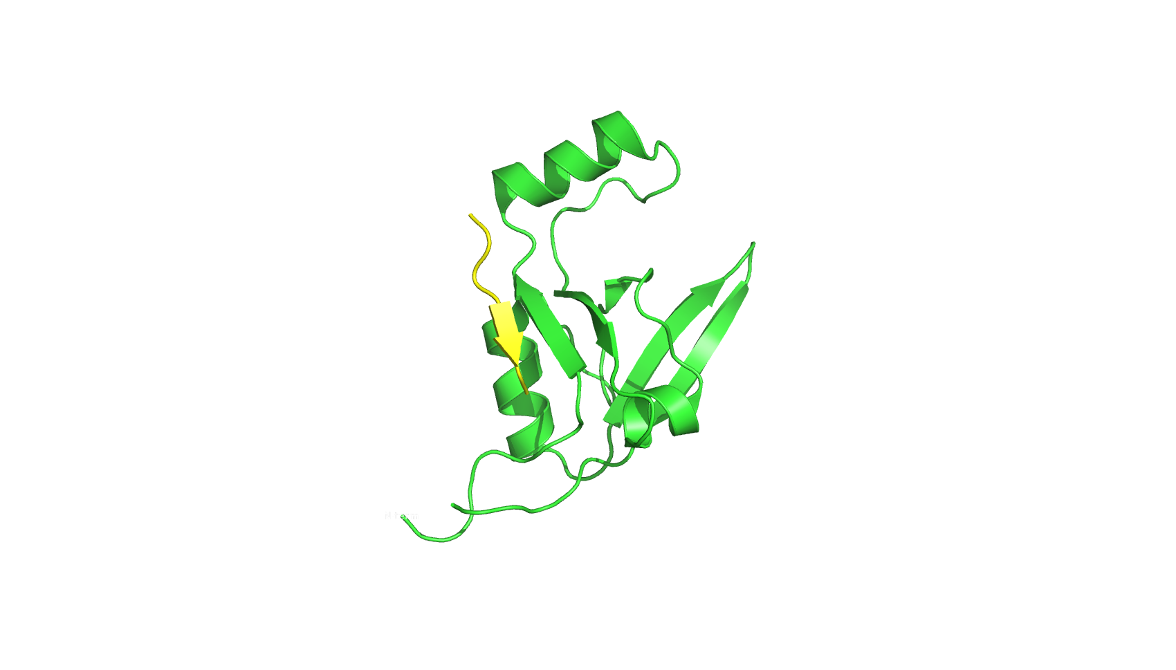 PDZ

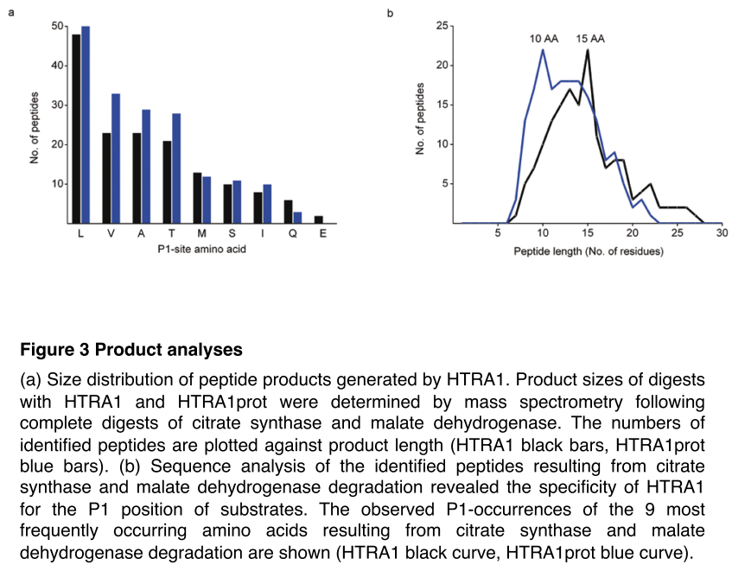

Eigenbrot 2012

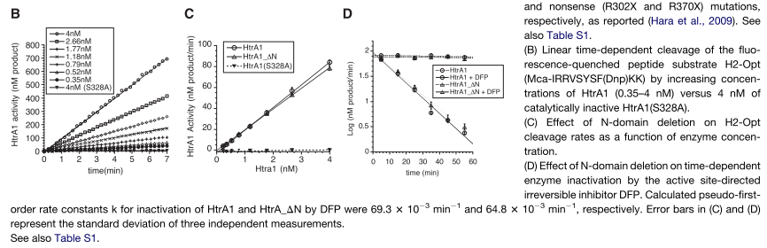

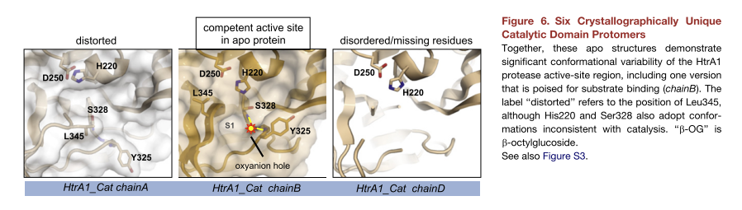

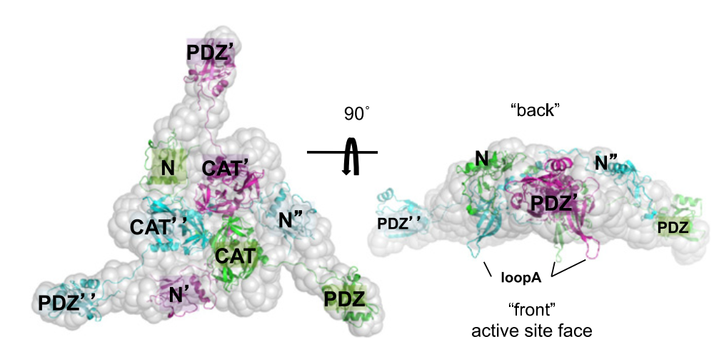

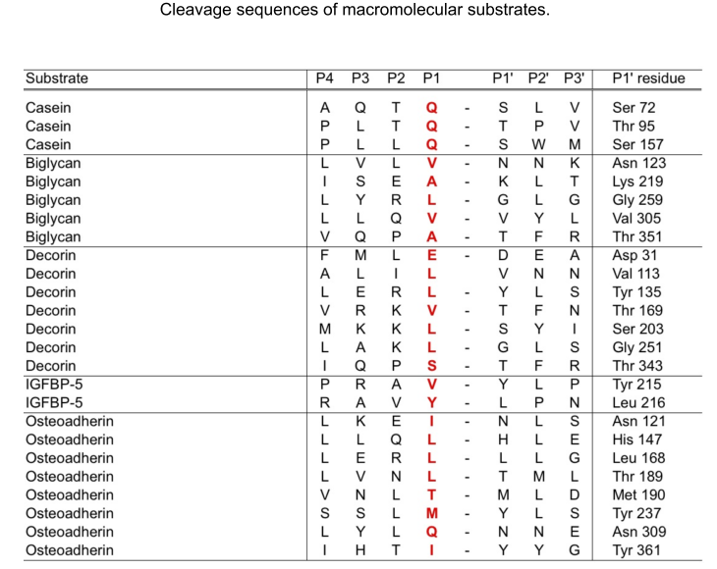

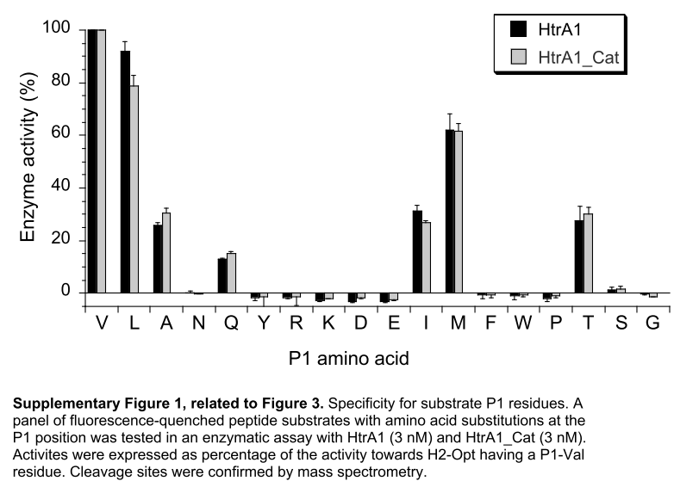

Tennstaedt 2012

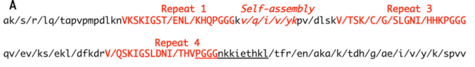

A, HTRA1 cleaves tau at multiple sites in its core domain which is relevant for aggregation. WT-, PHP-,and Ala-tau were completely digested by HTRA1. Proteolytic products were identified by mass spectrometry. Forward slashes indicate cleavage sites that were identical in the three tau variants analyzed. For simplicity, we show cleavage sites detected in tau Ala239–Val399, the region that is implicated in aggregation. The sequence of the synthetic substrate PGGGNKKIETHKL-pNA is underlined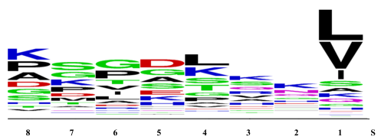

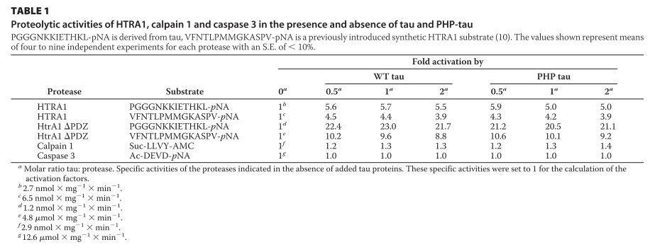

Poepsel 2015

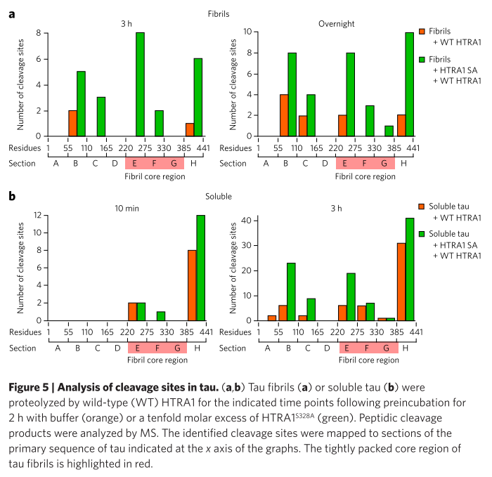

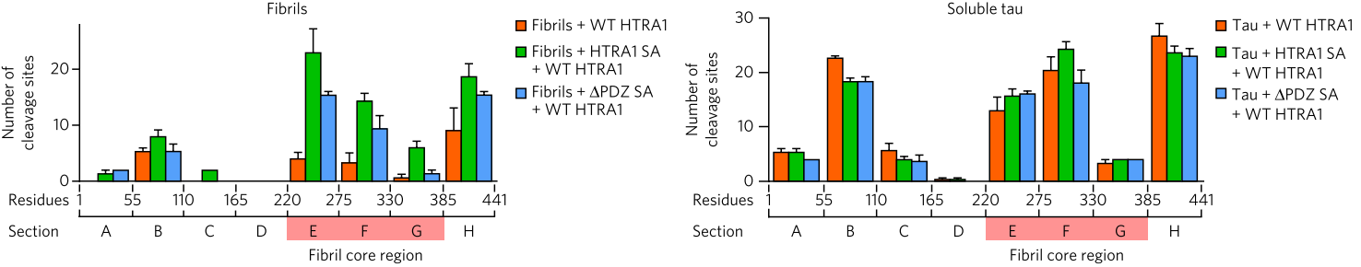

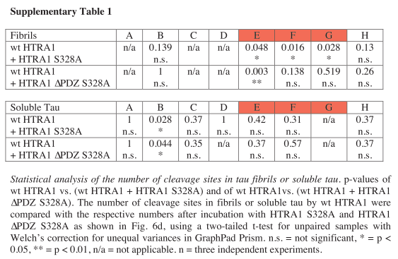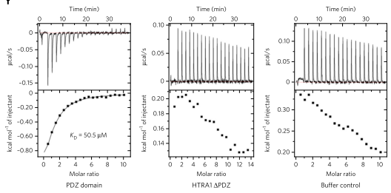

Binding of the tau peptide KTDHGAEIV (residues 385–393) to the PDZ domain of HTRA1 measured by ITC

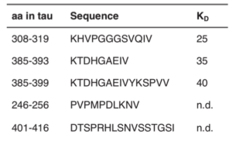 Binding with Htra1

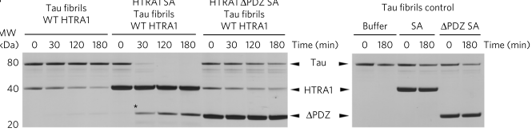

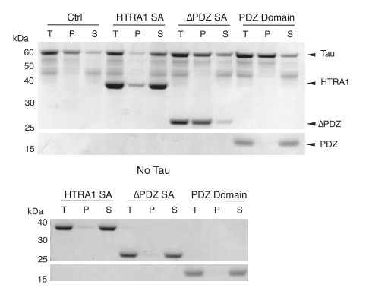

Tuttle 2016 Fitzpatrick 2017

